Recursively Enumerable Languages

These can be represented using a Turing machine.

Turing machine has an input tape and a read head which can move (right or left)

Tape is infinitely long. Consists of input symbols, and the rest is filled with blank symbols.

If Sigma is the input alphabet, and b is the blank symbol

W belongs to Sigma\* and b does not belong to Sigma

Tape can move either one space to the left or to the right.

Control logic - Turing machine normally contains a deterministic transition table similar to an FSA.

Functioning of Turing machine

1. Read current symbol from a cell in the tape  
   2) Writes to a cell  
   3) Moves one cell left or right

Transitions in the control logic

Of the form

a -> b, R

This means read symbol a, write b to the cell and move to the right.

Turing Machine

Defined by a 7 tuple

(Q, Sigma, Gamma, delta, q0, b, F)

Q - Non empty set of states

Sigma - non empty set of symbols

Gamma - Non empty set of tape symbols

Delta - transition function

Q0 - initial state

b- blank symbol, b belongs to Sigma

F - set of final states

Production rules

Delta(q,

Turing’s thesis

Any computation that can be performed by mechanical means can also be performed by a Turing machine. This means anything computable by a physical computer can be performed by a Turing machine.

Every regular language is also recursively enumerable.

Eg

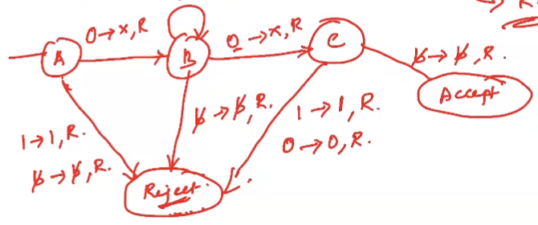

L = 01\*0 is accepted by this TM